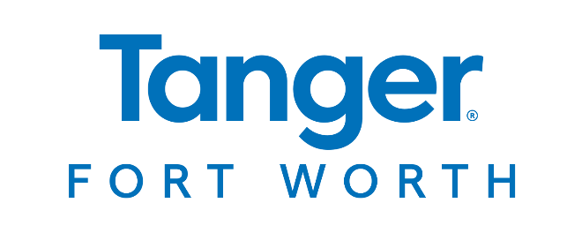

**For More Information**

Jayne Feldman

BRAVE Public Relations

404.233.3993

[jfeldman@emailbrave.com](mailto:jfeldman@emailbrave.com)

**\*MEDIA ADVISORY\***

**Tanger Outlets Fort Worth to Host Community Safety Fair, Sept. 28**

*Fort Worth shopping destination welcomes community for interactive safety event with first responders and their vehicles, a bicycle rodeo and more*

**FORT WORTH, Texas (Sept. 12, 2024) – Tanger Outlets Fort Worth** invites families to the Community Safety Fair on **Saturday, Sept. 28** from **10 a.m. – 1 p.m.** In partnership with the Fort Worth Police Department North Division, shoppers are invited to meet first responders and enjoy a close-up experience with their vehicles. The festivities, taking place in the parking lot behind ULTA Beauty, will feature a bicycle rodeo, archery demonstration, inflatable obstacle course, safety displays, food trucks and more for the whole family to enjoy.

**WHAT:** **Tanger Fort Worth Community Safety Fair**

*Guests will enjoy close-up experience with first responders and vehicles, food trucks and more*

**WHEN: Saturday, Sept. 28**10 a.m. – 1 p.m.

**WHERE: Tanger Outlets Fort Worth**

*Event is located in the parking lot behind ULTA Beauty*

15829 North Freeway

Fort Worth, TX 76177

**HOW:** This event is **FREE** to attend and open to the public.

To learn more about this and other upcoming events at Tanger Fort Worth, visit [tanger.com/fortworth](https://www.tanger.com/fortworth) – and connect on [Facebook](https://www.facebook.com/TangerOutletsFortWorth/) and [Instagram](https://www.instagram.com/tangeroutletsfortworth/?hl=en).

# # #